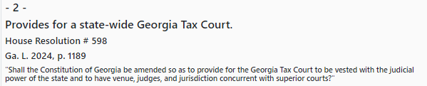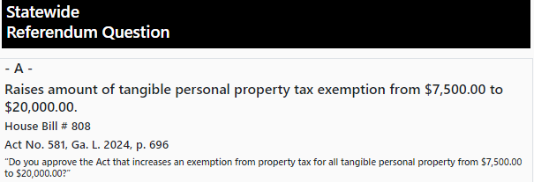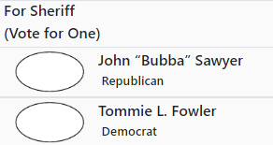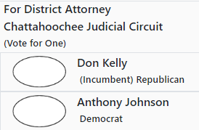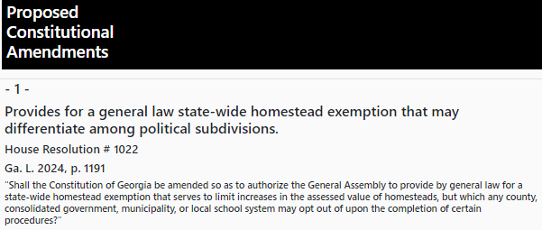

**Local Candidates with no opposition**

**County Commission:**

**District 1: Cicero Latimore**

**District 2: Tameka Harris**

**District 3: Jeff Watson**

**District 4: Dianne Renfroe**

**District 5: Randall F. Nelson**

**Board of Education:**

**District 1: Glenda Latimore**

**District 2: Al Townes**

**District 3: Greg Brown**

**District 4: C. Wayne McInvale II**

**District 5: Wes Summers**

**Coroner:**

**David McLeighton**

**Probate Judge:**

**Jennifer Williams**

**Clerk of Superior Court:**

**Lisa McDonald**

**Tax Commissioner:**

**Shirley Graham**